HYBRID VISION TRANSFORMER–GRAPH NEURAL NETWORK WITH RANDOM FOREST FEATURE ADAPTATION (VIT-GNN RFFA) FOR LIGHTWEIGHT LAND COVER CLASSIFICATION IN THE AMAZON BIOME

SYNOPSIS
This study presents a lightweight hybrid deep learning model, the Vision Transformer–Graph Neural Network with Random Forest Feature Adaptation (ViT-GNN RFFA), designed for efficient and accurate land cover classification in the Amazon biome. By leveraging compact, engineered feature vectors instead of raw pixels, the proposed model achieves state-of-the-art accuracy while significantly reducing computational complexity. Experimental results on the Amazon Rainforest dataset demonstrate superior performance in both accuracy and robustness compared to conventional pixel-based models, making ViT-GNN RFFA a scalable solution for environmental monitoring in resource-constrained contexts.
ABSTRACT
Accurate monitoring of the Amazon biome is critical for global climate stability and biodiversity conservation, yet it presents significant challenges for standard deep learning models due to their high computational cost. This study addresses the need for efficient and accurate land cover classification by proposing a lightweight, hybrid deep learning architecture, the Vision Transformer–Graph Neural Network with Feature Adaptation (ViT-GNN RFFA). Instead of operating on raw pixel data, the proposed model leverages a data-centric approach by processing a compact, 11-dimensional vector of engineered spectral, textural, and statistical features. The ViT-GNN RFFA was benchmarked against pixel-based models (Baseline CNN, MiniViT), a feature-based Random Forest, and an ablation version of itself operating on pixel data (ViT-GNN Plain). Results show that the ViT-GNN RFFA achieves a state-of-the-art Overall Accuracy of 0.938 with only 16,323 trainable parameters, a nearly four-fold reduction in complexity compared to its pixel-based counterparts. Furthermore, the model demonstrated a superior ability to correctly identify forest cover, achieving the lowest False Negative rate among all tested models. This study concludes that the proposed hybrid, feature-driven approach offers a practical and scalable solution, creating highly efficient yet powerful models suitable for large-scale environmental monitoring.
KEYWORDS
Amazon biome, land cover classification, hybrid deep learning, feature engineering, computational efficiency

Introduction
Accurate and timely monitoring of land cover in the Amazon biome is fundamental for global conservation efforts (DeArmond et al. 2023). While deep learning has shown promise, a significant scientific problem persists: a direct trade-off between model accuracy and computational efficiency. High-performance models like Vision Transformers (ViTs) are often computationally intensive, with high parameter counts, making them impractical for large-scale or resource-constrained monitoring applications(Jiao et al. 2023). Conversely, simpler models may be efficient but often lack the accuracy required for reliable analysis. This creates a critical gap for a methodology that can achieve high accuracy without the associated computational expense.
To address this challenge, the object of this study is the development and evaluation of a novel, lightweight, hybrid deep learning architecture named the Vision Transformer–Graph Neural Network with Feature Adaptation (ViT-GNN RFFA). The core innovation of this model is its departure from traditional pixel-based inputs. Instead, it is specifically designed to operate on a compact, information-rich vector of engineered features, aiming to prove that model complexity can be drastically reduced without sacrificing performance.
The methodology employed to resolve the stated problem is a hybrid data-centric and model-centric approach. The data-centric component involves a feature engineering process where raw pixel patches are transformed into a dense 11-dimensional vector, capturing key spectral, textural, and statistical properties. The model-centric component is the ViT-GNN RFFA architecture itself, which utilizes a dual-branch design: a ViT branch to interpret the feature vector as a whole sequence, and a GNN branch to explicitly model the inter-relationships between the individual features. This dual-pronged method is hypothesized to capture a more holistic understanding of the data than either a purely statistical or pixel-based model could achieve alone.
The primary scientific contribution of this work is the demonstration that this hybrid, feature-driven approach can produce a model that is both highly accurate and computationally superior for this task. This study provides empirical evidence that by intelligently pre-processing spatial data into a feature-based representation, a lightweight deep learning model can outperform its far larger, pixel-based counterparts. This finding offers a new direction for creating practical, scalable, and efficient solutions for critical environmental monitoring tasks in the Amazon and other sensitive biomes.

Related Works
Land cover classification has long been a central topic in remote sensing research, with early studies relying on statistical methods and traditional machine learning algorithms such as Support Vector Machines (SVM) and Random Forest (RF) that require extensive handcrafted feature engineering to achieve strong performance (Waske et al. 2010). SVMs are valued for their ability to handle high-dimensional data, but their accuracy depends heavily on effective feature selection (Zhou et al. 2024), while RF classifiers are widely used for their robustness and high accuracy, especially when combined with relevant feature selection techniques (Xu et al. 2023). Despite their effectiveness, these approaches are limited by the time-consuming nature of manual feature engineering and their inability to fully capture complex spatial hierarchies present in remotely sensed imagery (Barman and Mustak 2024). Recent advances in machine learning have addressed these challenges with deep learning models like Convolutional Neural Networks (CNNs), which can automatically extract hierarchical features from raw pixel data and consistently achieve superior accuracy (Fayaz et al. 2024). Ensemble learning approaches, such as DenseNet and EfficientNet, further boost classification robustness by integrating predictions from multiple models (Karolinoerita et al. 2025), while domain adaptation techniques help overcome the scarcity of labeled training data through semi-supervised and active learning methods (Bruzzone et al. 2016).
Despite the demonstrated potential of Vision Transformers and Graph Neural Networks for remote sensing applications, their practical deployment is still constrained by substantial computational costs and the need for large-scale annotated datasets (Jamali et al. 2024). This highlights a critical research gap: the development of more efficient hybrid architectures that can fully exploit both global and relational feature representations while remaining computationally feasible and less dependent on extensive labeled data (Russo et al. 2025). Current studies have begun to address this through hybrid ViT-GNN frameworks and the adoption of semi-supervised or data augmentation strategies, but challenges remain in achieving a balanced integration and scalable fusion of multimodal information (Zhang et al. 2024). Future research should therefore prioritize the creation of lightweight, adaptable models that can maintain high classification accuracy with limited data and resources, as well as explore more sophisticated approaches to cross-modal fusion and representation learning (Bai et al. 2025). By addressing these gaps, the next generation of remote sensing models will be better equipped for robust, scalable land cover classification in diverse and data-limited environments.
The present study addresses this gap by introducing a hybrid ViT-GNN RFFA model that operates on a compact, engineered feature vector, thus uniting the advantages of global context modeling from Vision Transformers, relational learning from Graph Neural Networks, and robust feature adaptation from Random Forests (Lu et al. 2025). By integrating these complementary components, the proposed approach effectively captures both broad and local patterns in remote sensing data, while maintaining a lightweight and data-efficient architecture (Han et al. 2022). This design not only enhances feature extraction and classification performance, especially on limited datasets, but also mitigates overfitting and boosts generalization due to the ensemble nature of Random Forests (Yuan et al. 2024). As a result, the ViT-GNN RFFA model demonstrates versatility and robustness, making it well-suited for a range of land cover classification and other challenging remote sensing tasks (Wu et al. 2023).

Methodology
The research workflow was designed to ensure a systematic and reproducible comparison, as illustrated in Figure 1. The methodology is structured into three primary stages. The first stage, Data & Feature Preparation, involves processing the raw satellite imagery to generate two distinct data types for the models: raw pixel patches and engineered feature vectors. The second stage, Model Training, follows a dual-track approach where pixel-based models are trained on the raw patches, while feature-based models, including the proposed ViT-GNN RFFA, are trained on the engineered vectors. The final stage, Evaluation & Analysis, comprises a comprehensive assessment of all models.
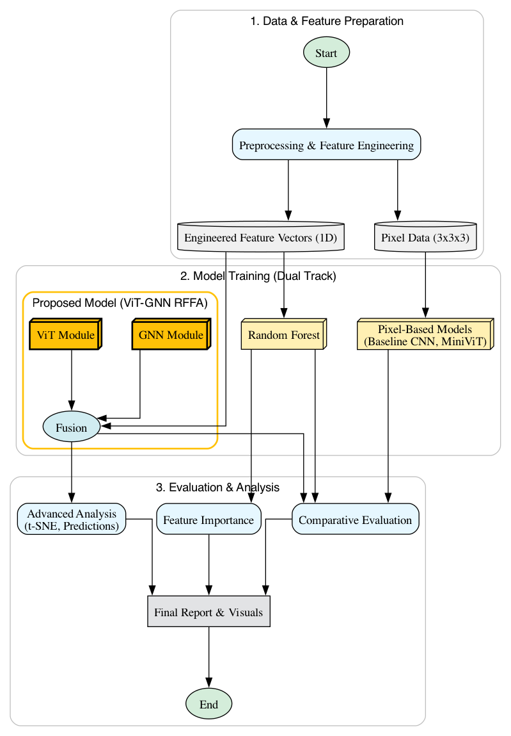
Figure 1. Pipeline Workflow

Dataset and Pre-processing
The dataset utilized in this study is the "Amazon Rainforest dataset for semantic segmentation" by Bragagnolo et al. (Bragagnolo et al. 2019). This public dataset consists of 512x512 pixel GeoTIFF images and their corresponding PNG masks. The dataset is pre-split into 30 images for training and 15 for validation, which were used as the basis for the training and testing sets in this research. To significantly augment the data, 200 random patches were sampled from each source image, resulting in a training set of 6,000 samples and a test set of 3,000 samples. Figure 2 Show the example of Amazon Rainforest dataset.
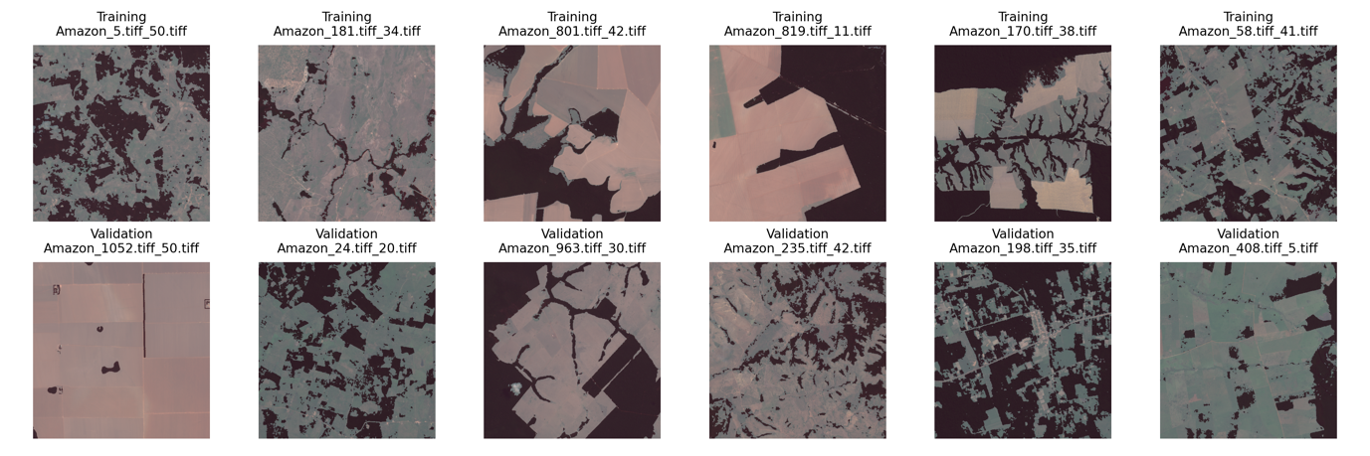
Figure 2. Amazon Rainforest Dataset

Feature Engineering
For each 3x3 pixel patch, a corresponding 11-dimensional feature vector was engineered from its surrounding 5x5 contextual area. These features include the mean values of the Red, Green, and Blue (RGB) channels; spectral band ratios analogous to NDVI; the standard deviation of RGB values from the 5x5 context; and the minimum, maximum, and median intensity values from the grayscale representation of the patch.

Comparative Model Architectures Several
models were employed as benchmarks. The Baseline CNN and MiniViT are pixel-based models. The Random Forest (RF) is a classic model trained on the engineered feature vectors. A ViT-GNN Plain model, which uses the same architecture as the proposed model but operates on flattened pixel data, was included as an ablation study to isolate the impact of feature engineering. The detailed architecture of each model is presented in Appendix A.
Output File (Appendix A): 6.1_model_architectures.txt

Proposed Model Architecture: ViT-GNN RFFA
The model proposed in this research, ViT-GNN RFFA (Figure 3), accepts the 11-dimensional feature vector as input. Its architecture leverages the complementary strengths of Vision Transformer (ViT) and Graph Neural Network (GNN) to enhance land cover classification from satellite imagery. The model processes engineered spectral and statistical features via two parallel branches: a ViT-based branch that captures global contextual relationships among features, and a GNN-based branch that models their local and relational dependencies. This dual-branch design allows the network to simultaneously exploit both holistic and structural aspects of the input data. Outputs from both branches are integrated using a Gated Fusion mechanism, which dynamically adjusts the contribution of each branch for every input. This adaptive fusion enables the model to selectively emphasize the most relevant information, leading to improved robustness and generalization. Experimental results show that this architecture outperforms baseline and plain variants, demonstrating superior sensitivity in distinguishing between ‘Forest’ and ‘Non-Forest’ classes across diverse and challenging samples.
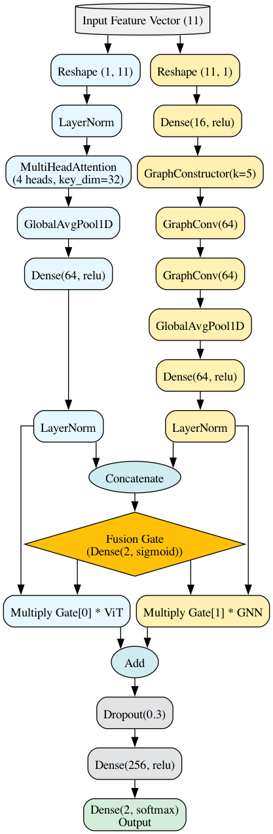
Figure 3. ViT-GNN FAA Architecture

Results
This section objectively presents the findings from the conducted experiments, beginning with an analysis of the engineered features, followed by a detailed assessment of the proposed model, and concluding with a comparative evaluation against benchmark models.

Feature Importance Analysis
The feature engineering approach was validated using a Random Forest model. The results in Figure 4 show that the G-R Ratio exhibits the highest importance, accounting for 28.5% of the total decision weight. This is followed by Mean R (17.4%), reinforcing the critical role of the red spectral band. Max Intensity (13.7%) and Median Intensity (11.2%) also provide substantial contributions, reflecting the significance of intensity-based features for land cover differentiation. Other features such as Min Intensity (9.0%), Mean B (4.9%), G-B Ratio (4.7%), and Mean G (4.0%) make incremental yet meaningful contributions to the classification task. The standard deviations—Std G (2.8%), Std R (2.4%), and Std B (1.5%)—though less dominant, still add value to the overall model performance. Collectively, these results confirm that while a small set of features predominantly drives the classification, the combination of all engineered features contributes to enhanced model accuracy and robustness.
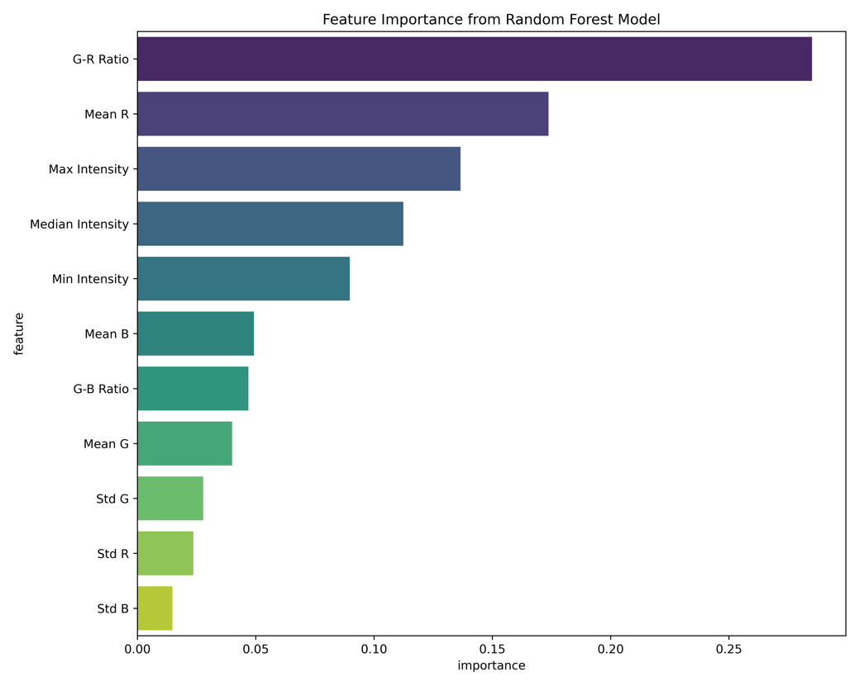
Figure 4. Feature Importance Plot

Performance of the Proposed ViT-GNN RFFA
The proposed ViT-GNN RFFA model, which utilizes the engineered features, demonstrated strong performance on the classification task. A comprehensive qualitative analysis provides deeper insight into the model’s behavior. Its confusion matrix (Figure 5) shows a high number of True Negatives (1431) and True Positives (1382), with a very low count of False Negatives (63), which is critical for forest monitoring.
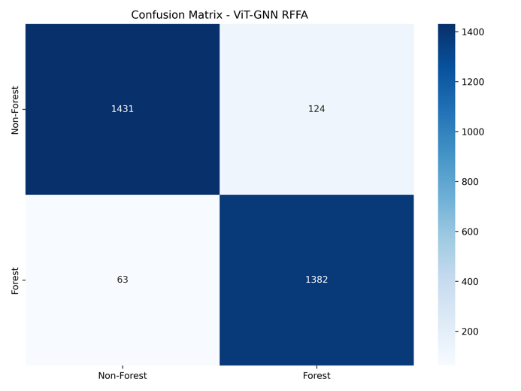
Figure 5. Confusion Matrix ViT-GNN FAA

To visualize the model’s learned representations, a t-SNE analysis was performed on the output of the final feature layer. As shown in Figure 6, the model projects the data into a low-dimensional space where the ‘Forest’ (label 1) and ‘Non-Forest’ (label 0) classes form largely distinct and separable clusters, confirming that the architecture has learned a discriminative feature space. Finally, Figure 7 provides a qualitative assessment through prediction examples, showcasing the model’s robustness in correctly classifying visually clear instances of both forest and non-forest land, while also highlighting that the few errors tend to occur on ambiguous, transitional patches.
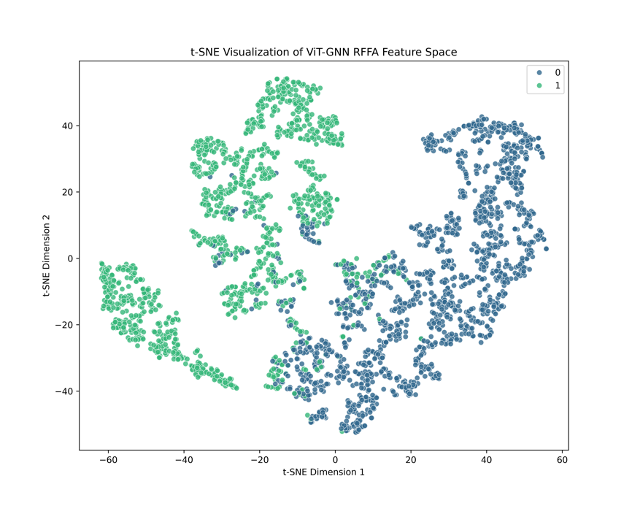
Figure 6. t-SNE Visualization ViT-GNN FAA
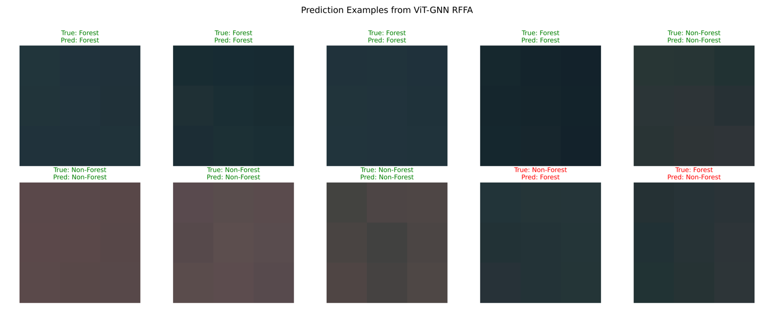
Figure 7. Prediction Examples ViT-GNN FAA

Comparative Analysis with Benchmark Models
The complete quantitative results are presented in Table 1. The proposed ViT-GNN RFFA model achieved the highest Overall Accuracy (0.938), Kappa Score (0.875), and F1-Score (0.938) among all models. It significantly outperformed the pixel-based models and also surpassed the Random Forest and the ViT-GNN Plain models, which do not benefit from the engineered features. While the Random Forest model is the fastest, its accuracy is slightly lower. Conversely, the MiniViT model, while performing well, has more than double the inference time of the ViT-GNN RFFA. This places the proposed model in an optimal position, delivering state-of-the-art accuracy with a highly efficient inference speed, second only to the much simpler Random Forest.

Table 1. Comparative Report
Model | Overall Accuracy | Kappa Score | F1-Score  (Macro) | Inference Time  (ms/sample)
ViT-GNN RFFA | 0.938 | 0.875 | 0.938 | 0.103
MiniViT | 0.931 | 0.861 | 0.931 | 0.173
ViT-GNN Plain | 0.929 | 0.859 | 0.929 | 0.086
Random Forest | 0.924 | 0.847 | 0.924 | 0.009
Baseline CNN | 0.916 | 0.833 | 0.916 | 0.046

Detailed Error Analysis via Confusion Matrices
The confusion matrices for all models are shown in Figure 5 and Figure 8. A key finding is the superior performance of the ViT-GNN RFFA (Fig. 5) in minimizing False Negatives (63), the Baseline CNN (Fig. 8a) correctly classified 1,352 'Forest' samples, but misclassified 93 as 'Non-Forest' (False Negatives), indicating limited sensitivity to forest cover. The MiniViT model (Fig. 8b) improved the detection of 'Forest', reducing the number of False Negatives to 69. The Random Forest model (Fig. 8c) achieved a False Negative count of 77, demonstrating competitive performance. The ViT-GNN Plain (Fig. 8d) produced 79 False These results confirm the superior ability of the ViT-GNN RFFA to correctly identify 'Forest' areas, highlighting the positive impact of feature engineering on model sensitivity in land cover classification.

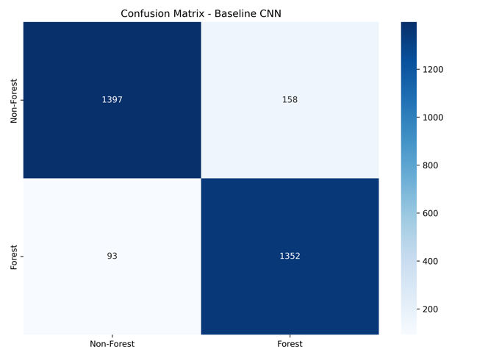  - Baseline CNN | 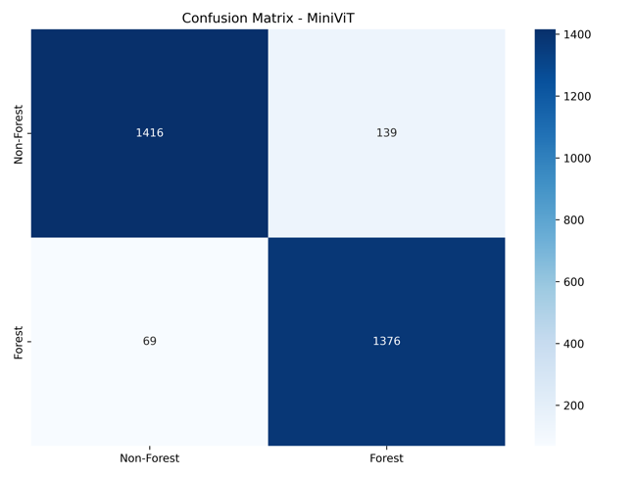  - MiniViT
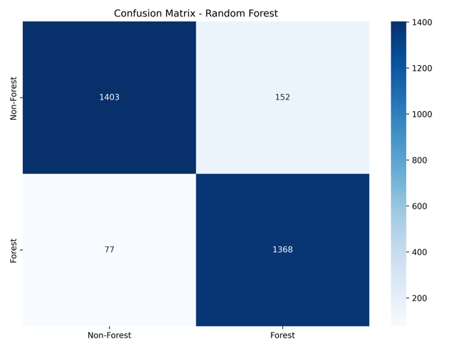  - Random Forest | 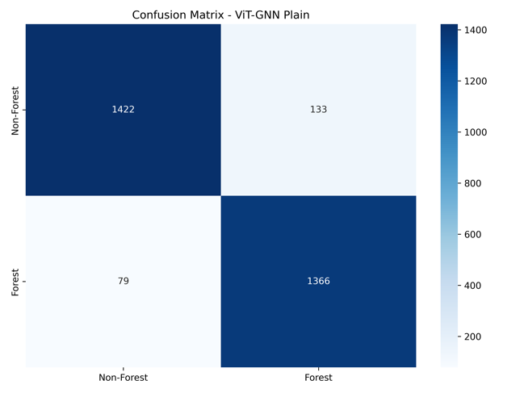  - ViT-GNN Plain
Figure 8. Comparison Confusion Matrices

Discussion

Analytical Summary and Key Finding
The experimental results conclusively demonstrate the superiority of the proposed ViT-GNN RFFA model. Its success stems from the hybrid, data-centric approach. By operating on a dense, 11-dimensional feature vector, the model's computational burden is drastically reduced while its access to high-level information is enhanced. The inclusion of the ViT-GNN Plain model serves as a crucial ablation study; its lower accuracy (0.929 vs 0.938) and higher False Negative rate (79 vs 63) compared to the ViT-GNN RFFA definitively prove that the feature engineering step, not just the architecture, is a critical component of the proposed method's success. The feature importance analysis (Figure 4) further explains this, showing that spectral indices and textural statistics, which are explicitly provided to the RFFA model, are highly discriminative.
Computational Efficiency of the Proposed ViT-GNN RFFA Model A key finding of this study is the vast difference in model complexity. The proposed ViT-GNN RFFA is exceptionally lightweight, with only 16,323 trainable parameters. This is in stark contrast to the pixel-based models, the Baseline CNN and MiniViT, which required 56,450 and 67,330 parameters, respectively. This disparity arises because pixel-based models must dedicate substantial capacity to learning basic representations from raw data, whereas the ViT-GNN RFFA allocates its entire, smaller parameter budget to modeling relationships between already meaningful features. This demonstrates a core principle of this study: intelligent feature engineering can lead to simpler, more efficient models without sacrificing performance. This efficiency has practical implications for deployment, enabling faster training and the potential for use in resource-constrained environments.

Limitations
This study has several limitations. The analysis is based on a single dataset, and the performance of the engineered features may vary across different satellite sensors or geographic regions. Furthermore, the feature engineering process was handcrafted; an end-to-end approach could potentially discover more optimal representations, albeit likely at a higher computational cost.

Future Work and Implications
Future work should involve validating the ViT-GNN RFFA model on diverse datasets from other parts of the Amazon biome. The lightweight nature of the model makes it a promising candidate for deployment in on-board satellite processing or for large-scale, time-series analysis. The findings imply that for specific remote sensing tasks, a hybrid data-centric and model-centric approach can yield solutions that are not only accurate but also significantly more practical and scalable than purely pixel-based paradigms.

Conclusion
This study successfully demonstrated the effectiveness of a hybrid approach that combines feature engineering with a lightweight ViT-GNN architecture. The proposed model, ViT-GNN RFFA, achieved superior classification performance and was significantly more efficient in terms of parameter count compared to standard pixel-based models. Furthermore, it exhibited the lowest False Negative rate, a critical requirement for deforestation monitoring. This finding underscores the importance of a data-centric approach in designing practical and efficient deep learning solutions for real-world problems such as land cover monitoring in the Amazon biome.

REFERENCES
Bai, J.; Chen, N.; Peng, J.; Wu, L.; Sun, W.; Ye, Z. 2025. HCAFNet: Hierarchical Cross-Modal Attention Fusion Network for HSI and LiDAR Joint Classification. IEEE Journal of Selected Topics in Applied Earth Observations and Remote Sensing 18: 9522–9532.
Barman, P.; Mustak, S. 2024. Assessing the performance of feature selection approach for urban Land Use/Cover Classification in Kolkata Metropolitan Area, India. 45th Asian Conference on Remote Sensing, ACRS 2024.
Bragagnolo, L.; da Silva, R.V.; Grzybowski, J.M.V. 2019. Amazon Rainforest dataset for semantic segmentation. .
Bruzzone, L.; Demir, B.; Bovolo, F. 2016. Recent advances in remote sensing time series image classification. In: Pattern Recognition and Big Data, p.713–734.
DeArmond, D.; Emmert, F.; Pinto, A.C.M.; Lima, A.J.N.; Higuchi, N. 2023. A Systematic Review of Logging Impacts in the Amazon Biome. Forests.
Fayaz, M.; Dang, L.M.; Moon, H. 2024. Enhancing land cover classification via deep ensemble network. Knowledge-Based Systems 305.
Han, K.; Wang, Y.; Guo, J.; Tang, Y.; Wu, E. 2022. Vision GNN: An Image is Worth Graph of Nodes. Advances in Neural Information Processing Systems 35.
Jamali, A.; Roy, S.K.; Pradhan, B. 2024. e-TransUNet: TransUNet provides a strong spatial transformation for precise deforestation mapping. Remote Sensing Applications: Society and Environment 35.
Jiao, J.; Tang, Y.M.; Lin, K.Y.; Gao, Y.; Ma, A.J.; Wang, Y.; et al. 2023. DilateFormer: Multi-Scale Dilated Transformer for Visual Recognition. IEEE Transactions on Multimedia.
Karolinoerita, V.; Ramadhani, F.; Cahyana, D.; Ramdhan, M.; Pryambodo, D.G.; Tarigan, S.D. 2025. Multisource Satellite Data Merge and Ensemble Machine Learning for Improved LULC Mapping Accuracy. Springer Proceedings in Physics 416 SPPHY: 131–140.
Lu, F.; Jia, K.; Zhang, X.; Sun, L. 2025. CRViT: Vision transformer advanced by causality and inductive bias for image recognition: CRViT: Vision transformer advanced by causality and inductive bias for image recognition: F. Lu et al. Applied Intelligence 55.
Russo, L.; Sorriso, A.; Ullo, S.L.; Gamba, P. 2025. A Deep Learning Architecture for Land Cover Mapping Using Spatio-Temporal Sentinel-1 Features. IEEE Journal of Selected Topics in Applied Earth Observations and Remote Sensing 18: 10562–10581.
Waske, B.; Van Der Linden, S.; Benediktsson, J.A.; Rabe, A.; Hostert, P. 2010. Sensitivity of support vector machines to random feature selection in classification of hyperspectral data. IEEE Transactions on Geoscience and Remote Sensing 48: 2880–2889.
Wu, J.; Li, J.; Zhang, J.; Zhang, B.; Chi, M.; Wang, Y.; et al. 2023. PVG: Progressive Vision Graph for Vision Recognition. MM 2023 - Proceedings of the 31st ACM International Conference on Multimedia: 2477–2486.
Xu, J.; Chen, C.; Zhou, S.; Hu, W.; Zhang, W. 2023. Land use classification in mine-agriculture compound area based on multi-feature random forest: a case study of Peixian. Frontiers in Sustainable Food Systems 7.
Yuan, L.; Zhang, W.; Zhang, N.; Yu, J.; Yang, W.; Zhang, W.; et al. 2024. Research on abnormal behavior detection algorithm of Internet of Things devices with computer vision assistance. 2024 IEEE 7th International Conference on Information Systems and Computer Aided Education, ICISCAE 2024: 247–251.
Zhang, Y.; Song, X.; Hua, Z.; Li, J. 2024. CGMMA: CNN-GNN Multiscale Mixed Attention Network for Remote Sensing Image Change Detection. IEEE Journal of Selected Topics in Applied Earth Observations and Remote Sensing 17: 7089–7103.
Zhou, X.; Han, T.; McCullum, K.; Wu, P. 2024. The Comparison of Machine Learning Techniques for Agricultural Land Use Classifications in the Prairies: A Case Study in Saskatchewan, Canada. Agricultural Research.

FIGURE LEGENDS
Figure 1. Pipeline workflow of the proposed study. The diagram illustrates the three major stages: data and feature preparation, model training, and evaluation.
Figure 2. Sample images from the Amazon Rainforest dataset used for training and validation. This figure is in color in the electronic version.
Figure 3. Architecture of the proposed ViT-GNN RFFA model. The design integrates Vision Transformer (ViT) and Graph Neural Network (GNN) branches, combined by a gated fusion mechanism.
Figure 4. Feature importance plot derived from the Random Forest model, highlighting the most discriminative engineered features (G–R ratio, Mean R, Max Intensity).
Figure 5. Confusion matrix of the ViT-GNN RFFA model. The model shows low false negative rates for forest cover classification.
Figure 6. t-SNE visualization of learned feature representations by the ViT-GNN RFFA. Forest and non-forest classes are clearly separable.
Figure 7. Prediction examples showing successful classification of forest and non-forest patches, as well as misclassified transitional areas. This figure is in color in the electronic version.
Figure 8. Comparative confusion matrices of benchmark models: (a) Baseline CNN, (b) MiniViT, (c) Random Forest, and (d) ViT-GNN Plain.

TABLE
Table 1. Comparative Report
Model | Overall Accuracy | Kappa Score | F1-Score  (Macro) | Inference Time  (ms/sample)
ViT-GNN RFFA | 0.938 | 0.875 | 0.938 | 0.103
MiniViT | 0.931 | 0.861 | 0.931 | 0.173
ViT-GNN Plain | 0.929 | 0.859 | 0.929 | 0.086
Random Forest | 0.924 | 0.847 | 0.924 | 0.009
Baseline CNN | 0.916 | 0.833 | 0.916 | 0.046

APPENDIX
Appendix A: Model Architecture Summaries
Appendix B: Detailed Prediction Table

